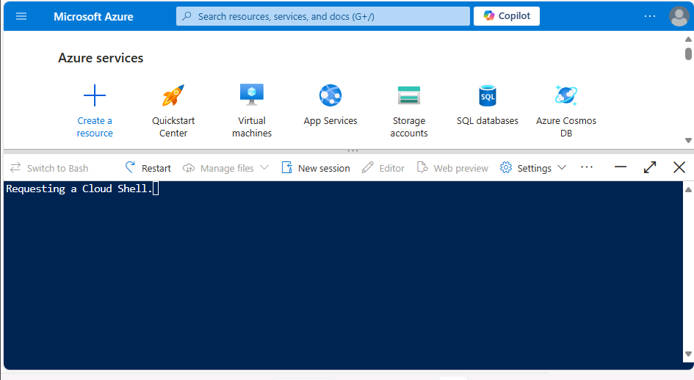**Tip**: As you follow the instructions in this pane, whenever you see a icon, you can use it to copy text from the instruction pane into the virtual machine interface. This is particularly useful to copy code; but bear in mind you may need to modify the pasted code to fix indent levels or formatting before running it!

Sign into Windows using the following credentials:

* **User name**: Student
* **Password**: Pa55w.rd

During the lab exercise, use the following credentials to sign into the MOC Subscription-lod49604596 Azure subscription that is provided for you:

* **User name**: User1-43739926@LODSPRODMCA.onmicrosoft.com
* **Password**: GAp40@g!eD

You will also use these credentials to access the Power BI service, but before you can do so you must complete the following steps to set up a trial Power BI account:

1. In the Windows virtual machine, install the latest version of Power BI Desktop by downloading and running **PBIDesktopSetup_x64.exe** from <https://www.microsoft.com/download/details.aspx?id=58494>. This may take some time.
2. After setup has finshed, launch Power BI Desktop.
3. Close the welcome screen, and then use the **Sign in** link to sign into Power BI Desktop using the credentials above.
4. When the Power BI service sign up page opens in the browser, sign in again with the same credentials as before and complete the process to create a Power BI service account.
5. Close the browser.

Create a realtime report with Azure Stream Analytics and Microsoft Power BI

Data analytics solutions often include a requirement to ingest and process *streams* of data. Stream processing differs from batch processing in that streams are generally *boundless* - in other words they are continuous sources of data that must be processed perpetually rather than at fixed intervals.

Azure Stream Analytics provides a cloud service that you can use to define a *query* that operates on a stream of data from a streaming source, such as Azure Event Hubs or an Azure IoT Hub. You can use an Azure Stream Analytics query to process a stream of data and send the results directly to Microsoft Power BI for realtime visualization.

In this exercise, you'll use Azure Stream Analytics to process a stream of sales order data, such as might be generated from an online retail application. The order data will be sent to Azure Event Hubs, from where your Azure Stream Analytics job will read and summarize the data before sending it to Power BI, where you will visualize the data in a report.

This exercise should take approximately **45** minutes to complete.

Before you start

You'll need an [Azure subscription](https://azure.microsoft.com/free) in which you have administrative-level access.

You'll also need access to the Microsoft Power BI service. Your school or organization may already provide this, or you can [sign up for the Power BI service as an individual](https://learn.microsoft.com/power-bi/fundamentals/service-self-service-signup-for-power-bi).

Provision Azure resources

In this exercise, you'll need an Azure Synapse Analytics workspace with access to data lake storage and a dedicated SQL pool. You'll also need an Azure Event Hubs namespace to which the streaming order data can be sent.

You'll use a combination of a PowerShell script and an ARM template to provision these resources.

1. Sign into the [Azure portal](https://portal.azure.com/) at https://portal.azure.com.
2. Use the **[>_]** button to the right of the search bar at the top of the page to create a new Cloud Shell in the Azure portal, selecting a ***PowerShell*** environment and creating storage if prompted. The cloud shell provides a command line interface in a pane at the bottom of the Azure portal, as shown here:

**Note**: If you have previously created a cloud shell that uses a *Bash* environment, use the the drop-down menu at the top left of the cloud shell pane to change it to ***PowerShell***.

1. Note that you can resize the cloud shell by dragging the separator bar at the top of the pane, or by using the **—**, **◻**, and **X** icons at the top right of the pane to minimize, maximize, and close the pane. For more information about using the Azure Cloud Shell, see the [Azure Cloud Shell documentation](https://docs.microsoft.com/azure/cloud-shell/overview).
2. In the PowerShell pane, enter the following commands to clone the repo containing this exercise:
3. rm -r dp-203 -f

git clone https://github.com/MicrosoftLearning/dp-203-azure-data-engineer dp-203

1. After the repo has been cloned, enter the following commands to change to the folder for this exercise and run the **setup.ps1** script it contains:
2. cd dp-203/Allfiles/labs/19

./setup.ps1

1. If prompted, choose which subscription you want to use (this will only happen if you have access to multiple Azure subscriptions).
2. While you are waiting for the script to complete, continue with the next task.

Create a Power BI workspace

In the Power BI service, you organize datasets, reports, and other resources in *workspaces*. Every Power BI user has a default workspace named **My Workspace**, which you can use in this exercise; but it's generally good practice to create a workspace for each discrete reporting solution you want to manage.

1. Sign into the Power BI service at <https://app.powerbi.com/> using your Power BI service credentials.
2. In the menu bar on the left, select **Workspaces** (the icon looks similar to 🗇).
3. Create a new workspace with a meaningful name (for example, *mslearn-streaming*), selecting the **Pro** licensing mode.

**Note**: If you are using a trial account, you may need to enable additional trial features.

1. When viewing your workspace, note its globally unique identifier (GUID) in the page URL (which should be similar to https://app.powerbi.com/groups/<GUID>/list). You will need this GUID later.

Use Azure Stream Analytics to process streaming data

An Azure Stream Analytics job defines a perpetual query that operates on streaming data from one or more inputs and sends the results to one or more outputs.

Create a Stream Analytics job

1. Switch back to the browser tab containing the Azure portal, and when the script has finished, note the region where your **dp203-*xxxxxxx*** resource group was provisioned.
2. On the **Home** page of the Azure portal, select **+ Create a resource** and search for Stream Analytics job. Then create a **Stream Analytics job** with the following properties:
   * **Subscription**: Your Azure subscription
   * **Resource group**: Select the existing **dp203-*xxxxxxx*** resource group.
   * **Name**: stream-orders
   * **Region**: Select the region where your Synapse Analytics workspace is provisioned.
   * **Hosting environment**: Cloud
   * **Streaming units**: 1
3. Wait for deployment to complete and then go to the deployed Stream Analytics job resource.

Create an input for the event data stream

1. On the **stream-orders** overview page, select the **Inputs** page, and use the **Add input** menu to add an **Event Hub** input with the following properties:
   * **Input alias**: orders
   * **Select Event Hub from your subscriptions**: Selected
   * **Subscription**: Your Azure subscription
   * **Event Hub namespace**: Select the **events*xxxxxxx\*** Event Hubs namespace
   * **Event Hub name**: Select the existing **eventhub*xxxxxxx\*** event hub.
   * **Event Hub consumer group**: Select the existing **$Default** consumer group
   * **Authentication mode**: Create system assigned managed identity
   * **Partition key**: *Leave blank*
   * **Event serialization format**: JSON
   * **Encoding**: UTF-8
2. Save the input and wait while it is created. You will see several notifications. Wait for a **Successful connection test** notification.

Create an output for the Power BI workspace

1. View the **Outputs** page for the **stream-orders** Stream Analytics job. Then use the **Add output** menu to add an **Power BI** output with the following properties:
   * **Output alias**: powerbi-dataset
   * **Select Power BI settings manually**: Selected
   * **Group workspace**: *The GUID for your workspace*
   * **Authentication mode**: *Select* **User token** *and then use the* **Authorize** *button at the bottom to sign into your Power BI account*
   * **Dataset name**: realtime-data
   * **Table name**: orders
2. Save the output and wait while it is created. You will see several notifications. Wait for a **Successful connection test** notification.

Create a query to summarize the event stream

1. View the **Query** page for the **stream-orders** Stream Analytics job.
2. Modify the default query as follows:
3. SELECT
4. DateAdd(second,-5,System.TimeStamp) AS StartTime,
5. System.TimeStamp AS EndTime,
6. ProductID,
7. SUM(Quantity) AS Orders
8. INTO
9. [powerbi-dataset]
10. FROM
11. [orders] TIMESTAMP BY EventEnqueuedUtcTime
12. GROUP BY ProductID, TumblingWindow(second, 5)

HAVING COUNT(*) > 1

Observe that this query uses the **System.Timestamp** (based on the **EventEnqueuedUtcTime** field) to define the start and end of each 5 second *tumbling* (non-overlapping sequential) window in which the total quantity for each product ID is calculated.

1. Save the query.

Run the streaming job to process order data

1. View the **Overview** page for the **stream-orders** Stream Analytics job, and on the **Properties** tab review the **Inputs**, **Query**, **Outputs**, and **Functions** for the job. If the number of **Inputs** and **Outputs** is 0, use the **↻ Refresh** button on the **Overview** page to display the **orders** input and **powerbi-dataset** output.
2. Select the **▷ Start** button, and start the streaming job now. Wait until you are notified that the streaming job started successfully.
3. Re-open the cloud shell pane and run the following command to submit 100 orders.

node ~/dp-203/Allfiles/labs/19/orderclient

1. While the order client app is running, switch to the Power BI app browser tab and view your workspace.
2. Refresh the Power BI app page until you see the **realtime-data** dataset in your workspace. This dataset is generated by the Azure Stream Analytics job.

Visualize the streaming data in Power BI

Now that you have a dataset for the streaming order data, you can create a Power BI dashboard that represents it visually.

1. Return to your PowerBI browser tab.
2. In the **+ New** drop-down menu for your workspace, select **Dashboard**, and create a new dashboard named **Order Tracking**.
3. On the **Order Tracking** dashboard, select the **✏️ Edit** menu, then select **+ Add a tile**. Then in the **Add a tile** pane, select **Custom Streaming Data** and select **Next**:
4. In the **Add a custom streaming data tile** pane, under **Your datasets**, select the **realtime-data** dataset, and select **Next**.
5. Change the default visualization type to **Line chart**. Then set the following properties and select **Next**:
   * **Axis**: EndTime
   * **Value**: Orders
   * **Time window to display**: 1 Minute
6. On the **Tile details** pane, set the **Title** to **Real-time Order Count** and select **Apply**.
7. Switch back to the browser tab containing the Azure portal, and if necessary, re-open the cloud shell pane. Then re-run the following command to submit another 100 orders.

node ~/dp-203/Allfiles/labs/19/orderclient

1. While the order submission script is running, switch back to the browser tab containing the **Order Tracking** Power BI dashboard and observe that the visualization updates to reflect the new order data as it is processed by the Stream Analytics job (which should still be running).

You can re-run the **orderclient** script and observe the data being captured in the real-time dashboard.

Delete resources

If you've finished exploring Azure Stream Analytics and Power BI, you should delete the resources you've created to avoid unnecessary Azure costs.

1. Close the browser tab containing the Power BI report. Then in the **Workspaces** pane, in the **⋮** menu for your workspace select **Workspace settings** and delete the workspace.
2. Return to the browser tab containing the Azure Portal, close the cloud shell pane, and use the **🗆 Stop** button to stop the Stream Analytics job. Wait for the notification that the Stream Analytics job has stopped successfully.
3. On the Azure portal, on the **Home** page, select **Resource groups**.
4. Select the **dp203-*xxxxxxx*** resource group containing your Azure Event Hub and Stream Analytics resources.
5. At the top of the **Overview** page for your resource group, select **Delete resource group**.
6. Enter the **dp203-*xxxxxxx*** resource group name to confirm you want to delete it, and select **Delete**.

After a few minutes, the resources created in this exercise will be deleted.

End the lab

Please be sure to end the lab.

**Project Overview**

**1. **Data Ingestion:**

* **Azure Stream Analytics** is used to ingest and process streaming data in real-time. It can handle data from various sources like IoT devices, social media, and application logs.
* **Azure Event Hubs** or **Azure IoT Hub** can be used as the input source for Azure Stream Analytics. These services capture and stream large amounts of data.

**2. **Data Processing:**

* **Stream Analytics Jobs** are created to process the incoming data. You can define queries using a SQL-like language to filter, aggregate, and transform the data.
* The processed data can be output to various destinations, including Azure Synapse Analytics, for further analysis.

**3. **Data Storage and Analysis:**

* **Azure Synapse Analytics** provides a powerful analytics service that combines big data and data warehousing. It allows you to store and analyze large volumes of data.
* The processed data from Azure Stream Analytics can be ingested into Azure Synapse Analytics for real-time analytics and reporting.

**Steps to Implement the Project**

1. **Set Up Input Sources:**
   * Create an **Azure Event Hub** or **Azure IoT Hub** to capture the streaming data.
   * Configure the input source in Azure Stream Analytics to connect to the Event Hub or IoT Hub.
2. **Create Stream Analytics Job:**
   * Define a Stream Analytics job in the Azure portal.
   * Configure the input to connect to the Event Hub or IoT Hub.
   * Write SQL-like queries to process the streaming data.
3. **Configure Output to Azure Synapse Analytics:**
   * Set up an output in the Stream Analytics job to send the processed data to Azure Synapse Analytics.
   * Ensure that the Synapse workspace and necessary tables are set up to receive the data.
4. **Run and Monitor the Job:**
   * Start the Stream Analytics job to begin processing the data.
   * Monitor the job’s performance and make adjustments as needed.
5. **Analyze Data in Azure Synapse Analytics:**
   * Use Synapse SQL or Spark to query and analyze the ingested data.
   * Create dashboards and reports to visualize the real-time data insights.

**Benefits**

* **Real-Time Processing:** Enables immediate insights from streaming data.
* **Scalability:** Can handle large volumes of data with ease.
* **Integration:** Seamlessly integrates with other Azure services for a comprehensive analytics solution.

Create a Stream Analytics job

1. Switch back to the browser tab containing the Azure portal, and when the script has finished, note the region where your **dp203-*xxxxxxx*** resource group was provisioned.
2. On the **Home** page of the Azure portal, select **+ Create a resource** and search for Stream Analytics job. Then create a **Stream Analytics job** with the following properties:
   * **Subscription**: Your Azure subscription
   * **Resource group**: Select the existing **dp203-*xxxxxxx*** resource group.
   * **Name**: stream-orders
   * **Region**: Select the region where your Synapse Analytics workspace is provisioned.
   * **Hosting environment**: Cloud
   * **Streaming units**: 1
3. Wait for deployment to complete and then go to the deployed Stream Analytics job resource.

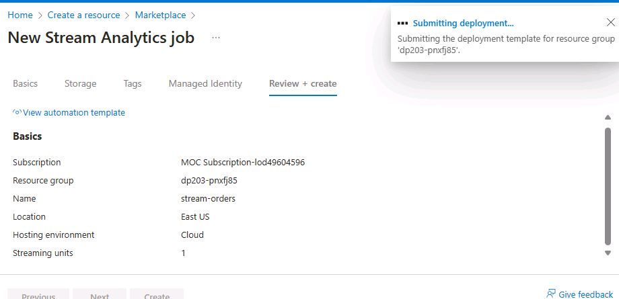

Create an input for the event data stream

1. On the **stream-orders** overview page, select the **Inputs** page, and use the **Add input** menu to add an **Event Hub** input with the following properties:
   * **Input alias**: orders
   * **Select Event Hub from your subscriptions**: Selected
   * **Subscription**: Your Azure subscription
   * **Event Hub namespace**: Select the ---events*xxxxxxx* Event Hubs namespace
   * **Event Hub name**: Select the existing--- eventhub*xxxxxxx* event hub.
   * **Event Hub consumer group**: Select the existing **$Default** consumer group
   * **Authentication mode**: Create system assigned managed identity
   * **Partition key**: *Leave blank*
   * **Event serialization format**: JSON
   * **Encoding**: UTF-8
2. Save the input and wait while it is created. You will see several notifications. Wait for a **Successful connection test** notification.

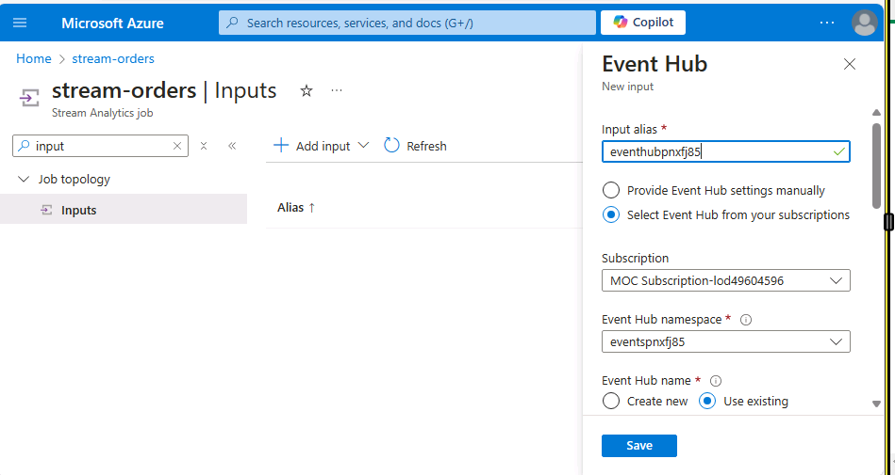

Create an output for the Power BI workspace

1. View the **Outputs** page for the **stream-orders** Stream Analytics job. Then use the **Add output** menu to add an **Power BI** output with the following properties:
   * **Output alias**: powerbi-dataset
   * **Select Power BI settings manually**: Selected
   * **Group workspace**: *The GUID for your workspace*
   * **Authentication mode**: *Select* **User token** *and then use the* **Authorize** *button at the bottom to sign into your Power BI account*
   * **Dataset name**: realtime-data
   * **Table name**: orders
2. Save the output and wait while it is created. You will see several notifications. Wait for a **Successful connection test** notification.

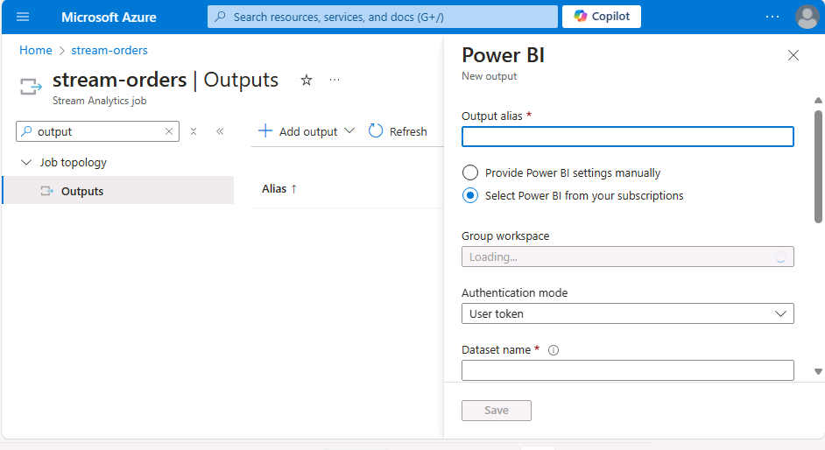

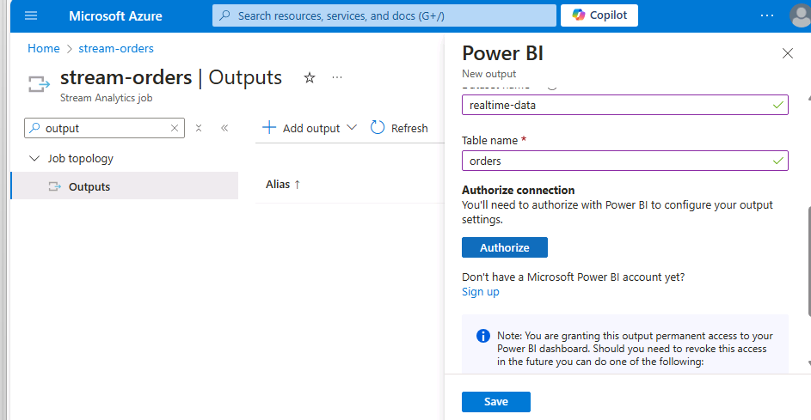

### Create a query to summarize the event stream

1. View the **Query** page for the **stream-orders** Stream Analytics job.
2. Modify the default query as follows:
3. SELECT
4. DateAdd(second,-5,System.TimeStamp) AS StartTime,
5. System.TimeStamp AS EndTime,
6. ProductID,
7. SUM(Quantity) AS Orders
8. INTO
9. [powerbi-dataset]
10. FROM
11. [orders] TIMESTAMP BY EventEnqueuedUtcTime
12. GROUP BY ProductID, TumblingWindow(second, 5)

HAVING COUNT(*) > 1

Observe that this query uses the **System.Timestamp** (based on the **EventEnqueuedUtcTime** field) to define the start and end of each 5 second tumbling (non-overlapping sequential) window in which the total quantity for each product ID is calculated.

1. Save the query.

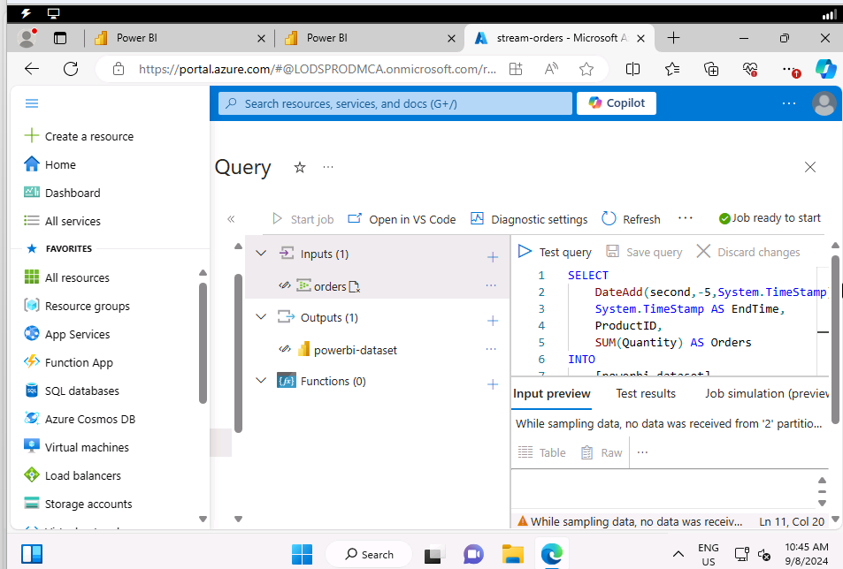

### Run the streaming job to process order data

1. View the **Overview** page for the **stream-orders** Stream Analytics job, and on the **Properties** tab review the **Inputs**, **Query**, **Outputs**, and **Functions** for the job. If the number of **Inputs** and **Outputs** is 0, use the **↻ Refresh** button on the **Overview** page to display the **orders** input and **powerbi-dataset** output.
2. Select the **▷ Start** button, and start the streaming job now. Wait until you are notified that the streaming job started successfully.
3. Re-open the cloud shell pane and run the following command to submit 100 orders.

node ~/dp-203/Allfiles/labs/19/orderclient

1. While the order client app is running, switch to the Power BI app browser tab and view your workspace.
2. Refresh the Power BI app page until you see the **realtime-data** dataset in your workspace. This dataset is generated by the Azure Stream Analytics job.

Visualize the streaming data in Power BI

Now that you have a dataset for the streaming order data, you can create a Power BI dashboard that represents it visually.

1. Return to your PowerBI browser tab.
2. In the **+ New** drop-down menu for your workspace, select **Dashboard**, and create a new dashboard named **Order Tracking**.
3. On the **Order Tracking** dashboard, select the **✏️ Edit** menu, then select **+ Add a tile**. Then in the **Add a tile** pane, select **Custom Streaming Data** and select **Next**:
4. In the **Add a custom streaming data tile** pane, under **Your datasets**, select the **realtime-data** dataset, and select **Next**.
5. Change the default visualization type to **Line chart**. Then set the following properties and select **Next**:
   * **Axis**: EndTime
   * **Value**: Orders
   * **Time window to display**: 1 Minute
6. On the **Tile details** pane, set the **Title** to **Real-time Order Count** and select **Apply**.
7. Switch back to the browser tab containing the Azure portal, and if necessary, re-open the cloud shell pane. Then re-run the following command to submit another 100 orders.

node ~/dp-203/Allfiles/labs/19/orderclient

1. While the order submission script is running, switch back to the browser tab containing the **Order Tracking** Power BI dashboard and observe that the visualization updates to reflect the new order data as it is processed by the Stream Analytics job (which should still be running).

You can re-run the **orderclient** script and observe the data being captured in the real-time dashboard.

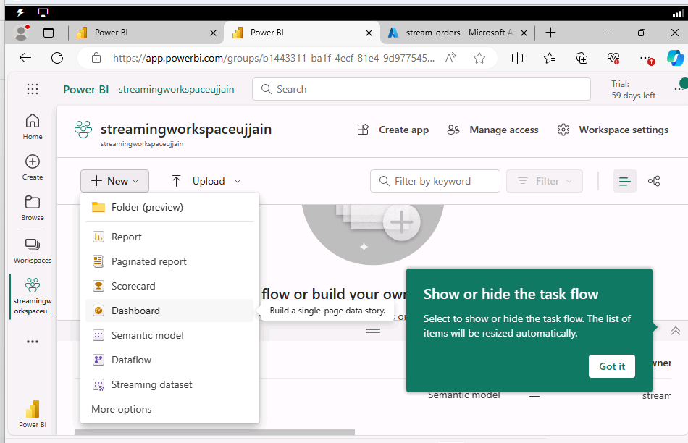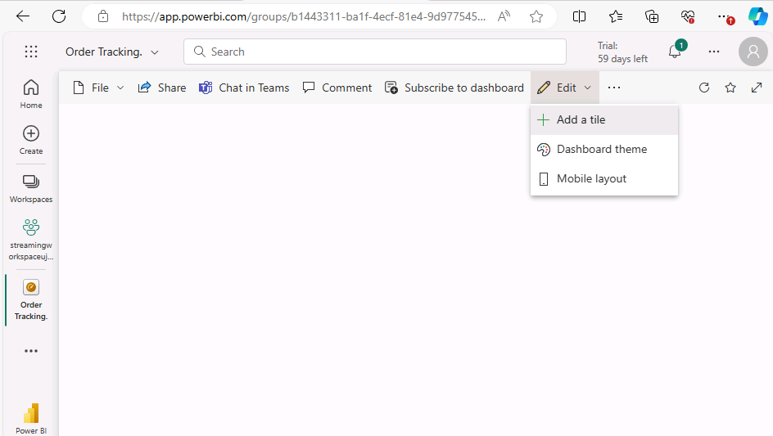

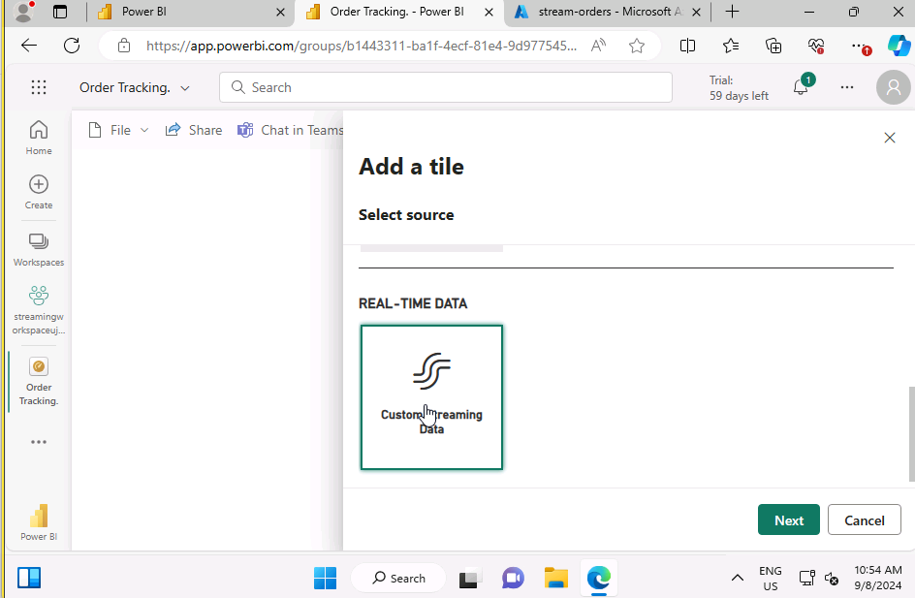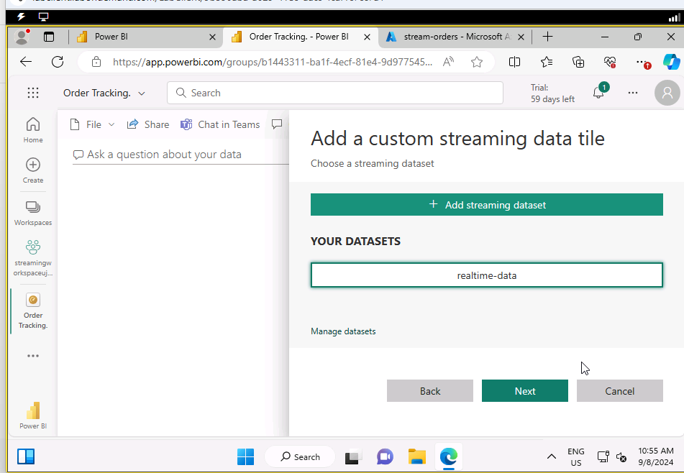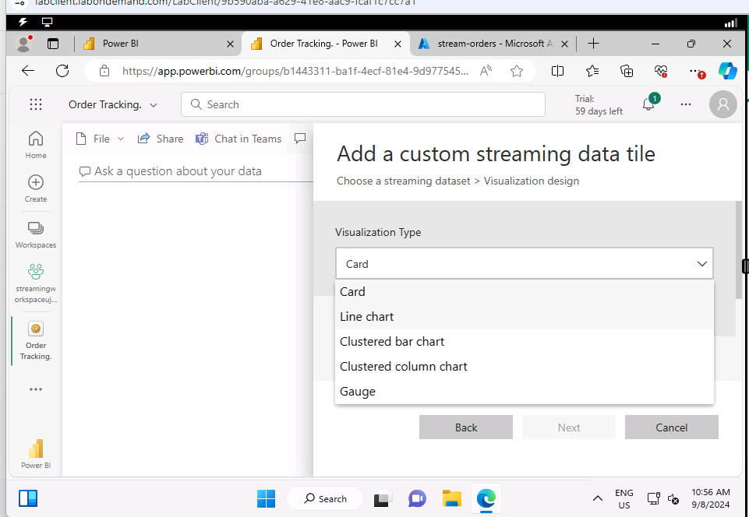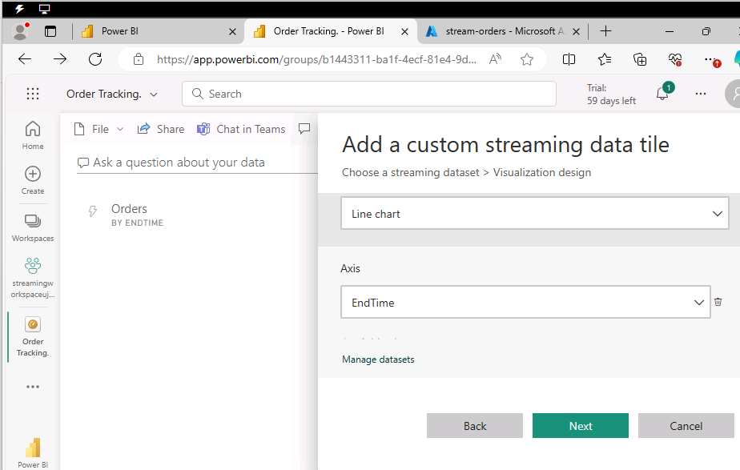

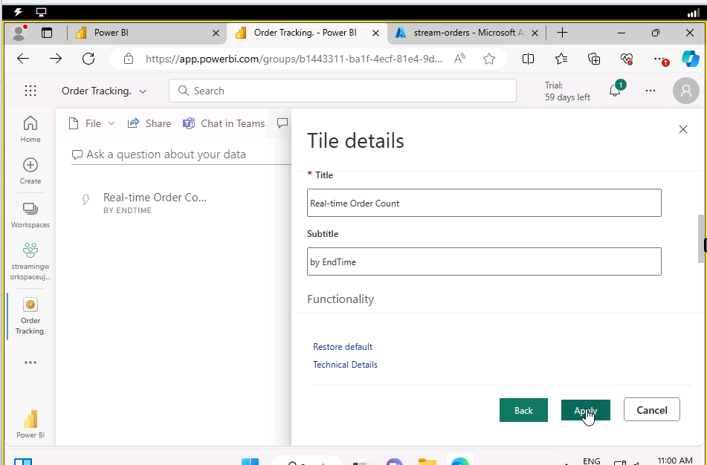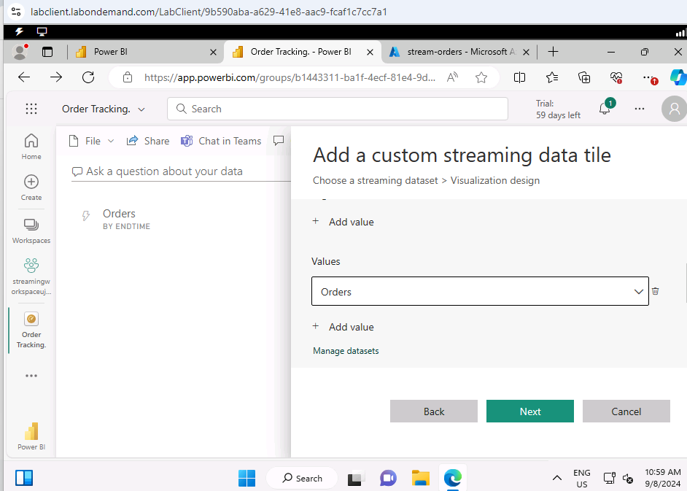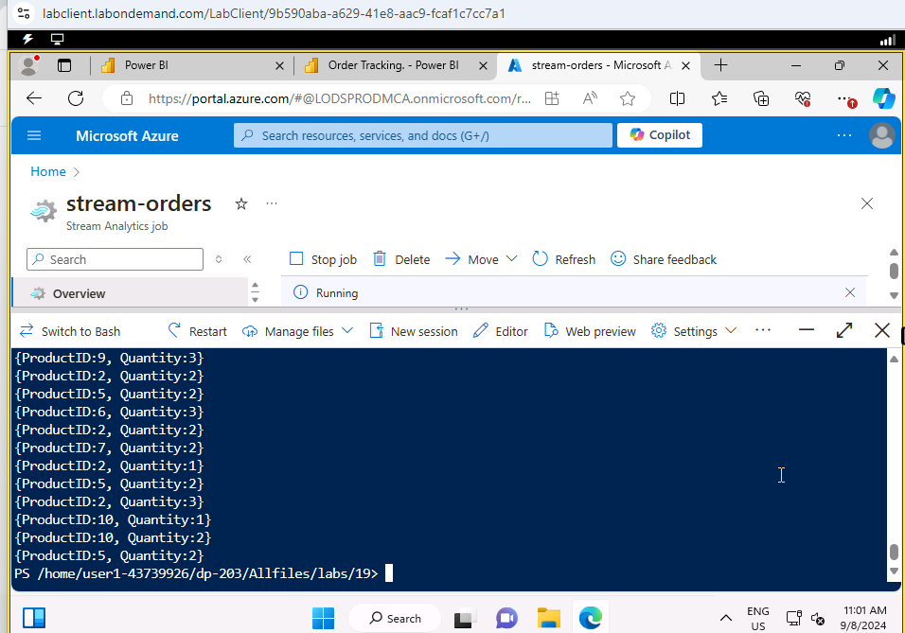

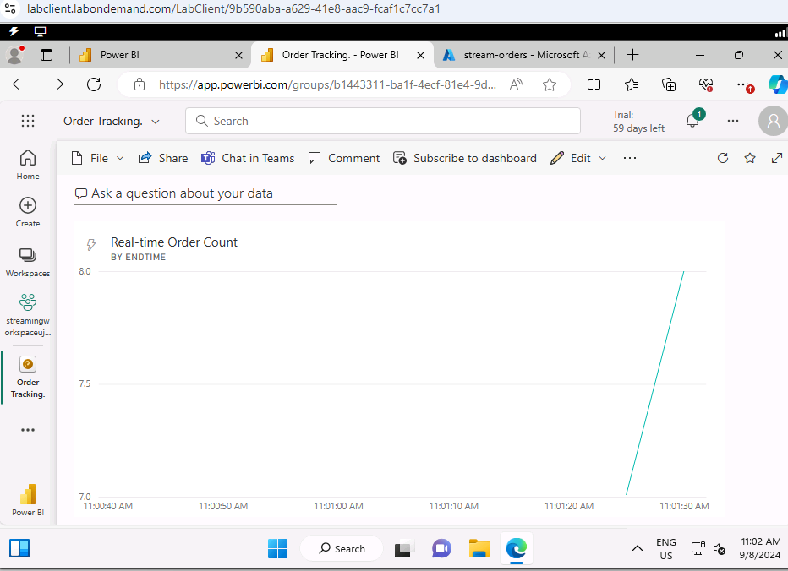

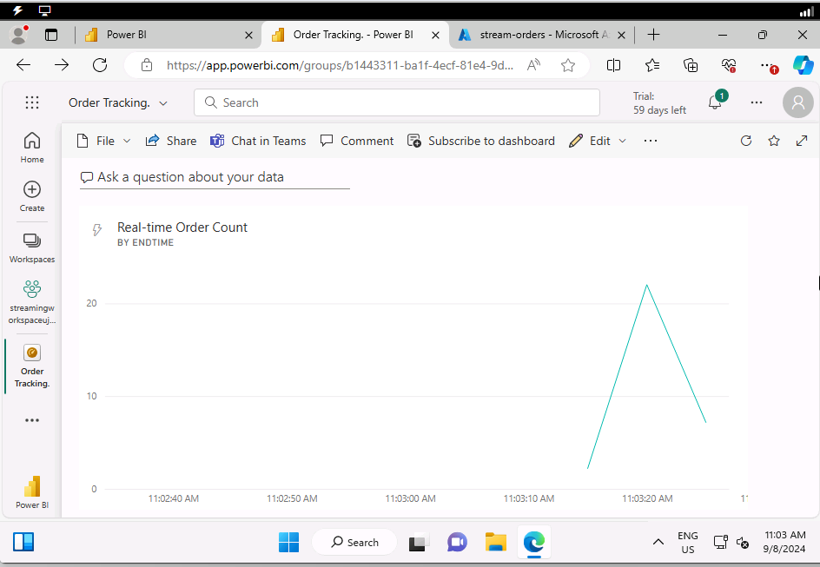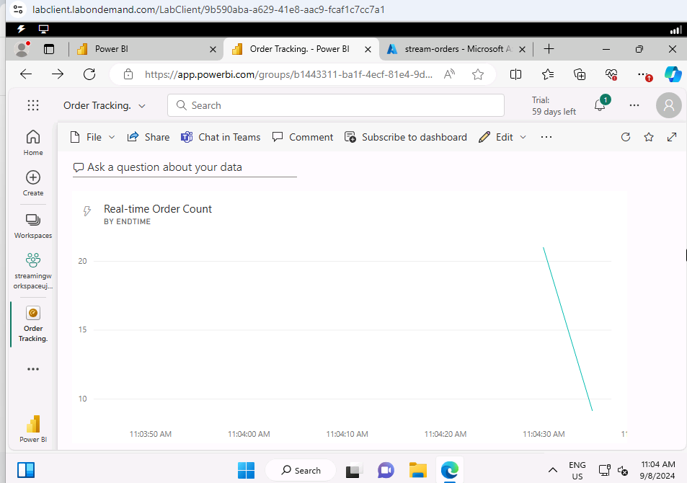

## Delete resources

If you've finished exploring Azure Stream Analytics and Power BI, you should delete the resources you've created to avoid unnecessary Azure costs.

1. Close the browser tab containing the Power BI report. Then in the **Workspaces** pane, in the **⋮** menu for your workspace select **Workspace settings** and delete the workspace.
2. Return to the browser tab containing the Azure Portal, close the cloud shell pane, and use the **🗆 Stop** button to stop the Stream Analytics job. Wait for the notification that the Stream Analytics job has stopped successfully.
3. On the Azure portal, on the **Home** page, select **Resource groups**.
4. Select the **dp203-xxxxxxx** resource group containing your Azure Event Hub and Stream Analytics resources.
5. At the top of the **Overview** page for your resource group, select **Delete resource group**.
6. Enter the **dp203-xxxxxxx** resource group name to confirm you want to delete it, and select **Delete**.

After a few minutes, the resources created in this exercise will be deleted.

### End the lab

Please be sure to end the lab.

